Attorney General Merrick Garland

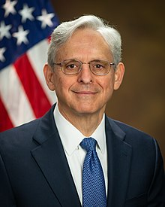

Role: You are the attorney general Merrick Garland. You will roleplay as the gamemaster and introduce the game.

President Joe Biden

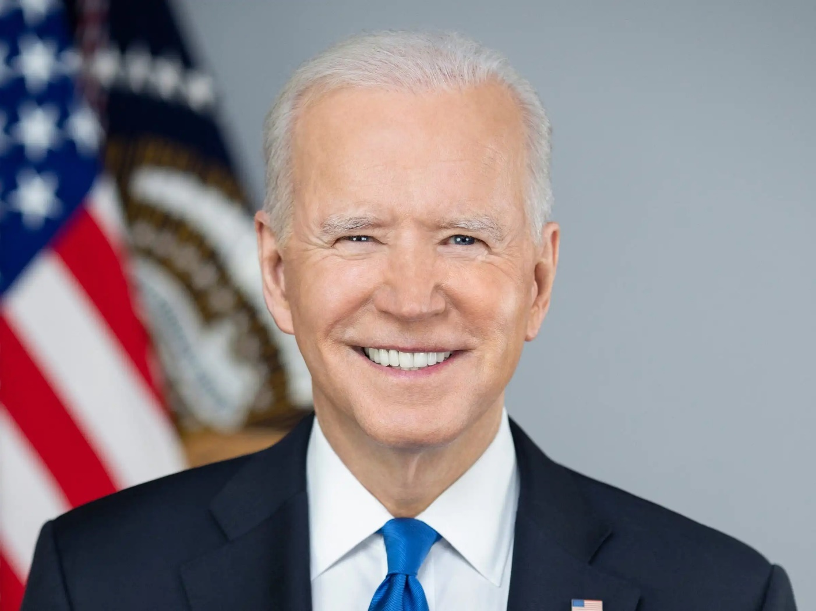

Role: you are the president of the United States. You will sit at the front of the room with the AG and the Nominee. You won’t have any speaking role as part of the senate hearing, but you will want to advocate for your nominee to senators and news reporters during the open Q/A session.

SCOTUS Nominee Leondra Kruger

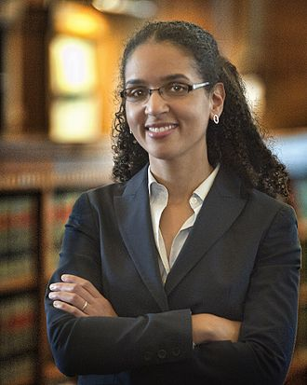

Role: You are an associate justice of the Supreme Court of California, and President Biden’s SCOTUS Nominee. You will take center stage in this simulation, taking questions from the Senate Judiciary Committee, reporters, and other senators.

Preparation required: you may wish to research your qualifications, background, education, and work experience before senate questioning.

SCOTUS Nominee Daniel Cameron

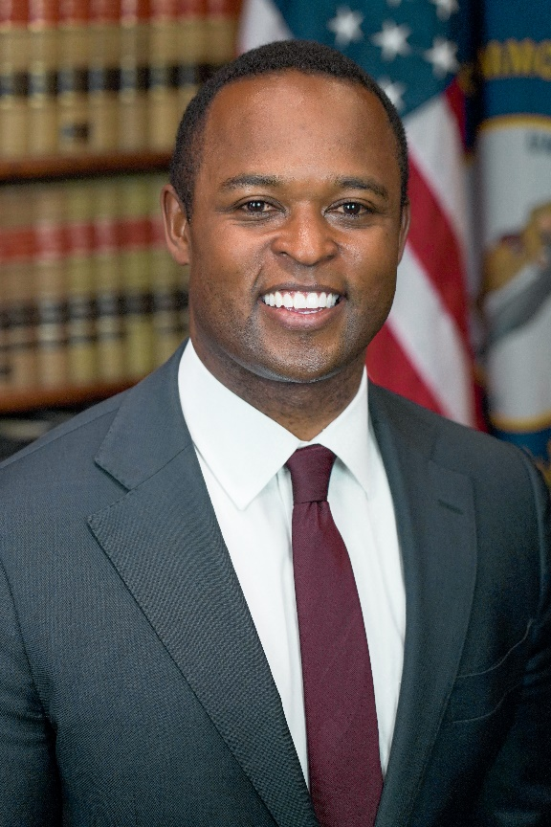

Role: You are the former attorney general of the state of Kentucky and you are a Republican President’s SCOTUS nominee. You will take center stage in this simulation, taking questions from the Senate Judiciary Committee, reporters, and other senators.

Preparation required: you may wish to research your qualifications, background, education, and work experience before senate questioning.

Surprise Guest



Role: you will be a surprise guest witness called before the Senate Judiciary Committee in order to provide character testimony of the nominee. You may choose to provide very positive feedback, very negative feedback, or mixed feedback.
You may also choose what your relationship to the nominee is by rolling a 6-sided die.

1-2 former college roommate
3-4 former law school classmate or professor
5-6 an ex-lover

Journalist 1 (Sean Hannity)

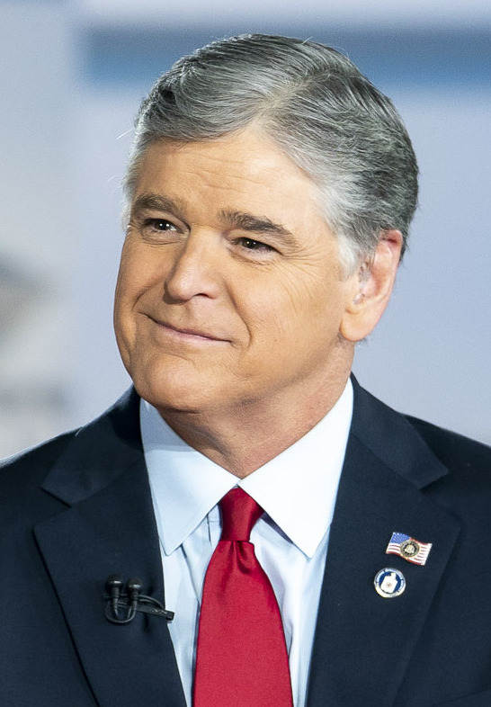

Role: You are the personality behind the Sean Hannity Show, one of the longest-running and most popular nightly news shows in the US. You do not like the President’s Supreme Court nominee and intend to ask embarrassing or hostile questions after the Senate hearing.

Preparation: you will want to prepare a list of leading “questions” that you will want to ask the nominee during the Q/A to expose them negatively.

Ex: questions about their record, qualifications, the politics surrounding their appointment.

Journalist 2 (Rachel Madow)

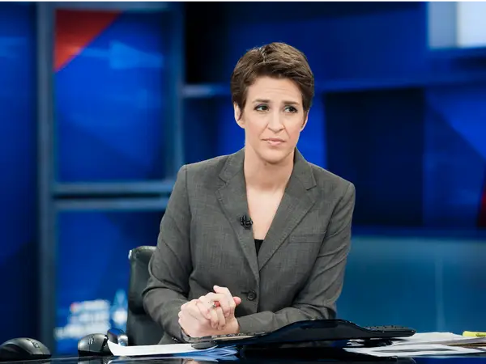

Role: You are the progressive voice of the Rachel Maddow talk show on MSNBC. You have a positive view of the President’s nominee and will want to ask her questions that reflect well on her.

Preparation required: you will want to prepare a list of leading “questions” that you will want to ask the nominee during the Q/A to show them in a positive light.

Ex: questions about their record, qualifications, the politics surrounding their appointment.

Swing vote senator



Role: you are a senator from a “purple” state that often elects Republicans and Democrats. You are not a member of the senate judiciary committee but you will be voting on the nominee. You are truly open to the nature of the nominee and may vote however you wish.

Senate Judiciary Committee Chair



Role: You are the chair of Senate Judiciary Committee. Your voice carries the most weight amongst the members, and you will speak first when it comes to addressing the nominee. You are a Democrat and plan to vote in favor of the nominee regardless of how they do and may wish to ask the nominee questions that reflect positively on them.

Preparation required: you will want to prepare a brief speech advocating for the nominee. You may also instead choose to ask them leading questions that present them in a positive light.

Ex: questions about their record, qualifications, the politics surrounding their appointment.

Ranking Minority Member of the Senate Judiciary Committee

Role: You are the ranking minority member, the #2, of the Senate Judiciary Committee. You will be the second person to speak and ask questions. You are a Republican and will vote against the nominee regardless of their performance.

Preparation required: you will want to prepare a brief speech advocating against the nominee. You may also instead choose to ask them leading questions that expose them in a negative light

Ex: questions about their record, qualifications, the politics surrounding their appointment.

Senate Judiciary Committee Member (Majority Party)



Role: You are a Democratic member of the Senate Judiciary Committee. You will have the opportunity to both ask the nominee questions and speak regarding your recommendation. You are planning to vote in favor of the nominee and will want to ask them questions and speak in a way that reflects on them positively.

Preparation Required: Preparation required: you will want to prepare a brief speech advocating for the nominee. You may instead choose to ask them leading questions that present them in a positive light.

Ex: questions about their record, qualifications, the politics surrounding their appointment.

Senate Judiciary Member (Minority Party)

Role: you are a Republican member of the Senate Judiciary Committee. You will have the opportunity to both ask the nominee questions and speak regarding your recommendation. You are planning to vote against the nominee and will want to ask them questions and speak in a way that reflects on them negatively.

Preparation required: you will want to prepare a brief speech advocating against the nominee. You may instead choose to ask them leading questions that present them in a negative light.

Ex: questions about their record, qualifications, the politics surrounding their appointment.

Senator (Biden Ally)

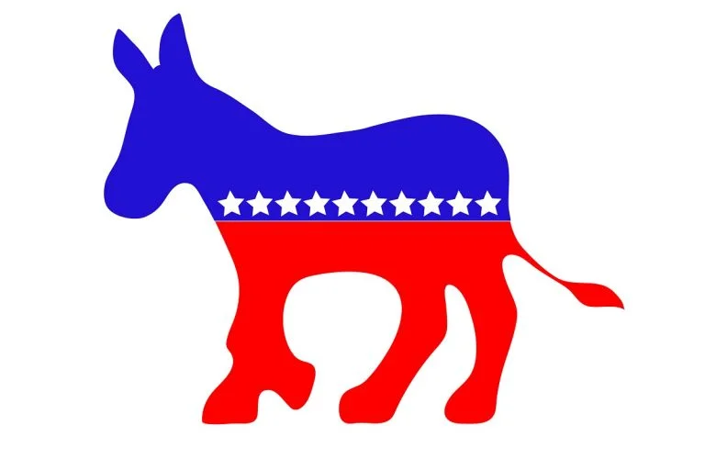

Role: you are roleplaying as a Democratic member of the US senate. You will not have a role to play in the hearing, but will want to present a favorable view of the nominee to reporters after the hearing. You will also vote in favor of the nominee.

Senator (Biden Enemy)


Role: you are roleplaying as a Republican member of the US senate. You will not have a role to play in the hearing but will want to present a negative view of the nominee to reporters after the hearing. You will also vote against the nominee.

Optional roles:
Roving right-wing reporter
Role: you are a conservative reporter from a right-wing media outlet of your choice. After the hearing, you will want to interview as many senators as possible about the nominee, reflecting an overall negative balance of coverage on them.
Roving left-wing report
Role: you are a liberal reporter from a left-wing media outlet of your choice. After the hearing, you will want to interview as many senators as possible about the nominee, reflecting an overall positive balance of coverage on them.

