UNIVERSITY OF SOUTHERN INDIANA
SCHOOL OF NURSING AND HEALTH PROFESSIONS
NUTR 376: Principles and Applications in Nutrition

Diet Diary Project – Part 1

Michaela Jones

Day 1 Food Record Wednesday, February 19, 2020
Time | Food & Beverage Description | Amount eaten | Hunger rating out of 10 | Location/Feelings
7:00 am | Pancake | 1 each | 4/7 | Home - relaxed and reading
 | Bacon | 1 slice
 | 2% milk | 8 ounces
10:30 am | Angel hair pasta | ½ cup | 2/6 | Home - relaxed and doing homework
 | Ground beef | 2 tablespoons
 | Pasta Sauce | ¼ cup
 | Shredded mozzarella cheese | 2 tablespoons
 | Spinach | ½ cup
 | Romaine lettuce | ½ cup
 | Parmesan cheese | 1 teaspoon
 | Caesar dressing | 1 teaspoon
 | Water | 8 ounces
2:15 pm | Chicken sandwich (fried) at Chick-Fil-A | 1 each | 3/7 | School- Exhausted from class
 | Chick-Fil-A Honey roasted BBQ sauce | 2 tablespoons
 | Water | 8 ounces
3:00 pm | Raspberries | ¼ cup | 7/8 | School - Craving something sweet
 | Strawberries | ½ cup
4:20 pm | Water | 8 ounces
5:15 pm | Kettle corn PopCorners | 1 ounce | 6/7 | School - Bored and waiting for class to start
 | Water | 4 ounces
7:45 pm | Romaine lettuce | 1 cup | 4/5 | Home – tired but trying to focus on homework
 | Parmesan cheese | 1 teaspoon
 | Caesar dressing | 1.5 teaspoons
 | Water | 8 ounces

Day 2 Food Record Thursday, February 20, 2020
Time | Food & Beverage Description | Amount eaten | Hunger rating out of 10 | Location/Feelings
5:30 am | Pillsbury biscuit | 3 ounces | 2/6 | Work – tired
 | Water | 4 ounces
9:30 | Water | 8 ounces
11:15 | Yakitori chicken with Japanese style fried rice | 1.75 cups | 2/7 | Work - rushed
 | Water | 4 ounces
1:00 pm | Water | 4 ounces
4:00 pm | Bread, Great Value, 100% whole wheat | 2 slices | 1/8 | Home - exhausted and hungry!
 | Colby jack cheese | 1 ounce
 | Campbell’s tomato soup | 10.75 ounces
 | 2% milk | 6 ounces
 | Water | 4 ounces
8:30 pm | Grilled Angus beef | 5 ounces | 2/9 | Hardees – tired and hungry
 | Sourdough bread | 2 each
 | Swiss cheese | 1 ounce
 | Tomato | 1 ounce
 | Leaf lettuce | 2 each
 | Mayo | 2 teaspoons
 | Bacon | 2 slices
 | Fries | ½ cup
 | Ketchup | 2 tablespoons

Day 3 Food Record Saturday February 29, 2020
Time | Food & Beverage Description | Amount eaten | Hunger rating out of 10 | Location/Feelings
10:30 am | Orange, fresh | ½ cup | 4/5 | Home - relaxed
11:00 am | 100% Whole wheat toast | 2 slices | 5/9 | Home - happy
 | Simply Orange: Orange juice | 8 ounces
 | Bacon | 3 slices
 | Over-easy egg | 1 each
 | Sharp cheddar cheese | 1 ounce
 | Mayo | 2 teaspoons
 | Cooked spinach | ½ cup
2:00 pm | Iced French Vanilla Coffee | 12 ounces | 5/8 | Home – not very hungry but feel like I should eat
 | Great northern beans | ¼ cup
 | Ground beef | ¼ cup
 | Pinto beans | ¼ cup
 | Kidney beans | ¼ cup
 | Tomato sauce | ¼ cup
4:00 pm | Water | 8 ounces
7:00 pm | 6-inch French bread | 1 each | 2/9 | Subway- Hungry!
 | Steak | 3 ounces
 | Provolone cheese | 1 ounce
 | Lettuce | 1/3 cup
 | Tomato | 2 ounces
 | Green bell peppers | 2 tablespoons
 | Sweet Onion sauce | 1 tablespoon
 | Water | 8 ounces
8:00 pm | White chocolate chip macadamia cookie – 3 in diameter | 2 each | 8/9 | Home - relaxed
 | 2% milk | 5 ounces
10:20 pm | Water | 8 ounces |  | Home – doing homework
12:00 am | Cheerios | ¾ cup | 2/7 | Home- About to go to bed but suddenly started feeling hungry to the point of being sick
 | Banana | 1 each
 | 2% milk | ¾ cup

UNIVERSITY OF SOUTHERN INDIANA
SCHOOL OF NURSING AND HEALTH PROFESSIONS
NUTR 376: Principles and Applications in Nutrition

Diet Diary Project – Part 2

Michaela Jones

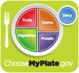
Intake vs. Recommendation Report
2200 Calorie Pattern
Group |  | Percent |  | Comparison | Amount | *
Grains Intake 110 %7.7 oz equivalent
Grains Recommendation7.0 oz equivalent
Vegetables Intake 57 %1.7 cup equivalent
Vegetables Recommendation3.0 cup equivalent
Fruits Intake 54 %1.1 cup equivalent
Fruits Recommendation2.0 cup equivalent
Dairy Intake 72 %2.2 cup equivalent
Dairy Recommendation3.0 cup equivalent
Protein Foods Intake 116 %7.0 oz equivalent
Protein Foods Recommendation6.0 oz equivalent

Actual Intakes -vs- Recommended Intakes Report
The actual intakes -vs- recommended intakes report displays the amount of nutrients consumed as they compare to your dietary intake recommendations.
Nutrient | Actual | Rec. Percent
Basic Components
Calories | 2,017. | 2,121.9 | 95%
Calories from Fat | 656.07 | 594.15 | 110% 20-35% of Calories (adults 19+ yrs)*
Calories from SatFat | 211.18 | 190.98 | 111% Less than 10% of Calories+
Protein (g) | 93.12 | 43.54 | 214% 10-35% of Calories (adults 19+ yrs)*~
Carbohydrates (g) | 250.15 | 291.77 | 86% 45-65% of Calories (adults 19+ yrs)*
Total Sugars (g) | 84.29
Added Sugar (g)++ | 2.80 |  | Less than 10% of Calories+
Dietary Fiber (g) | 20.99 | 29.71 | 71%
Soluble Fiber (g) | 1.55
InSoluble Fiber (g) | 2.53
Fat (g) | 72.90 | 66.02 | 110% 20-35% of Calories (adults 19+ yrs)*
Saturated Fat (g) | 23.46 | 21.22 | 111% Less than 10% of Calories+
Trans Fat (g) | 1.12 |  | Minimize+
Mono Fat (g) | 10.59 | 23.58 | 45%
Poly Fat (g) | 6.99 | 21.22 | 33%
Cholesterol (mg) | 242.50 | 300.00 | 81% Limit+
Water (g) | 1,396. | 2,700.0 | 52%
Vitamins
Vitamin A - RAE (mcg)
657.25
700.00
94
%
Beta-carotene (mcg)
3,435.
Vitamin B1 - Thiamin (mg)
0.94
1.10
86
%
Vitamin B2 - Riboflavin
1.24
1.10
112
%
Vitamin B3 - Niacin (mg)
10.93
14.00
78
%
Vitamin B6 (mg)
1.03
1.30
79
%
Do not exceed 100 mg*
Vitamin B12 (mcg)
3.43
2.40
143
%
Over 50 should take a supplement or eat fortified foods*
Vitamin C (mg)
100.98
75.00
135
%
Vitamin D - mcg (mcg)
4.49
15.00
30
%
15
to no more than 100 mcg*
Vitamin E - a-Toco (mg)
2.71
15.00
18
%
Folate (mcg)
353.72
400.00
88
%
Women of child-bearing age should take a supplement or
fortified foods with 400 mcg*
Minerals
Calcium (mg)
1,051.
1,000.0
105
%
Do not exceed 2500 mg*
Iron (mg)
14.25
18.00
79
%
Do not exceed 45 mg*
Magnesium (mg)
180.66
310.00
58
%
Do not exceed 350 mg by supplement*
Phosphorus (mg)
728.41
700.00
104
%
Do not exceed 4000 mg*
Potassium (mg)
2,467.
4,700.0
52
%
At least 4700 mg per day*
Selenium (mcg)
41.26
Sodium (mg)
4,269.
2,300.0
186
%
Less than 2300 mg per day* - less than 1500 mg for some
people+
Zinc (mg)
7.52
8.00
94
%
Do not exceed 40 mg*
Other
Omega-3 (g)
0.58
Omega-6 (g)
4.35
Alcohol (g)
0.00
Do not exceed 2 standard drinks for men and 1 standard
drink for women+
Caffeine (mg)
1.18
Up to 400 mg (three to five 8-oz cups of coffee per day)+
* Dietary Reference Intakes
+ 2015 Dietary Guidelines for Americans
++The nutrient content of the items in the MDA food database depend on manufacturers' reporting accurate information. Since many do not have data yet on added sugars, this number may not be an accurate reflection of added sugar intake.
~ Protein recommendations have not been adjusted to take into account endurance/strength athletes who fall into the active and very active categories, but do take into account pregnancy and lactation.
Recommendations Report
The Recommendations Report lists the recommended daily nutrient intake for a person based on the information entered. Often referred to as the DRI (Dietary Reference Intake).
Nutrient | Value Notes
Basic Components
Calories | 2,121.96
Protein (g) | 43.54 | 10-35% of Calories (adult 19+ yrs)*~
Carbohydrates (g) | 291.77 | 45-65% of Calories (adult 19+ yrs)*
Added Sugar (g) ++ |  | Less than 10% of Calories+
Dietary Fiber (g) | 29.71
Fat (g) | 66.02 | 20-35% of Calories (adult 19+ yrs)*
Saturated Fat (g) | 21.22 | Less than 10% of Calories +
Mono Fat (g) | 23.58
Poly Fat (g) | 21.22
Cholesterol (mg) | 300.00 | Limit+
Water (g) | 2,700.00
Vitamins
Vitamin A - RAE (mcg) | 700.00
Vitamin B1 - Thiamin (mg) | 1.10
Vitamin B2 - Riboflavin (mg) | 1.10
Vitamin B3 - Niacin (mg) | 14.00
Vitamin B6 (mg) | 1.30 | Do not exceed 100 mg *
Vitamin B12 (mcg) | 2.40 | Over 50 should take a supplement *
Vitamin C (mg) | 75.00
Vitamin D - mcg (mcg) | 15.00 | 15 to no more than 100 mcg*
Vitamin E - Alpha Toc. (mg) | 15.00
Folate (mcg) | 400.00 | Women of child-bearing age should take a supplement or fortified foods with 400 mcg*
Minerals
Calcium (mg) | 1,000.00 | Do not exceed 2500 mg *
Iron (mg) | 18.00 | Do not exceed 45 mg *
Magnesium (mg) | 310.00 | Do not exceed 350 mg by supplement *
Phosphorus (mg) | 700.00 | Do not exceed 4000 mg *
Potassium (mg) | 4,700.00 | At least 4700 mg per day*
Sodium (mg) | 2,300.00 | Less than 2300 mg per day* - less than
1500 mg for some people+
Zinc (mg) | 8.00 | Do not exceed 40 mg *
MyFoodList Report

Amount |  | Item |  | Cals
Day 1
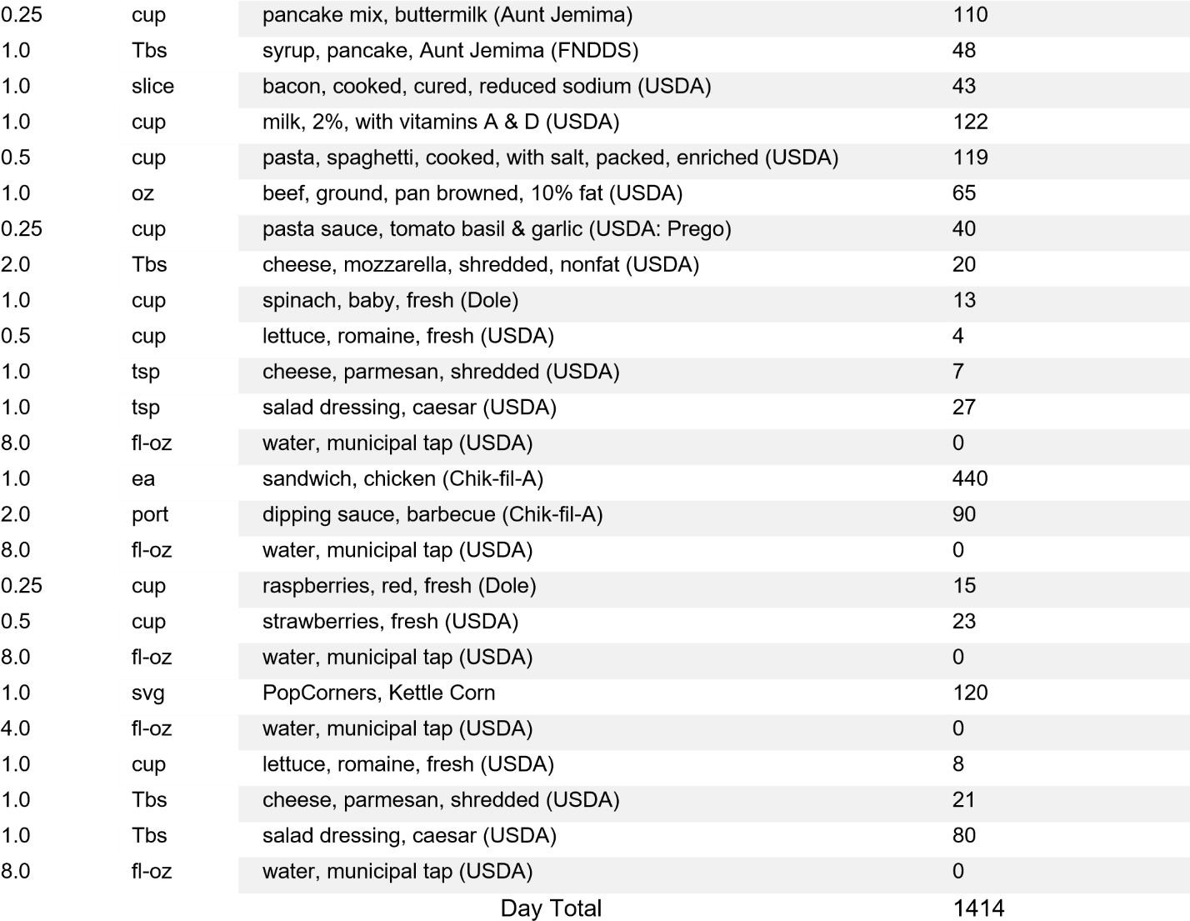
Day 2
170
ea
1.0
biscuit dough, southern style, Grands!, frozen (Pillsbury)
0
fl-oz
4.0
water, municipal tap (USDA)
360
cup
1.75
yakitori chicken, frozen, with japanese style fried rice
0
fl-oz
8.0
water, municipal tap (USDA)
200
slice
2.0
bread, 100% whole wheat (Sara Lee Hearty & Delicious)
101
oz
1.0
cheese, colby jack (Kraft)
225
cup
1.25
soup, tomato, canned, condensed (Campbell's)
85
oz
6.0
milk, 2%, with vitamins A & D (USDA)
0
fl-oz
4.0
water, municipal tap (USDA)
840
ea
1.0
cheeseburger, Frisco, 1/3 lb (Hardee's)
229
sml
1.0
french fries (USDA: McDonald's)
30
Tbs
2.0
ketchup, food service (Hunt's)
Day Total 2241
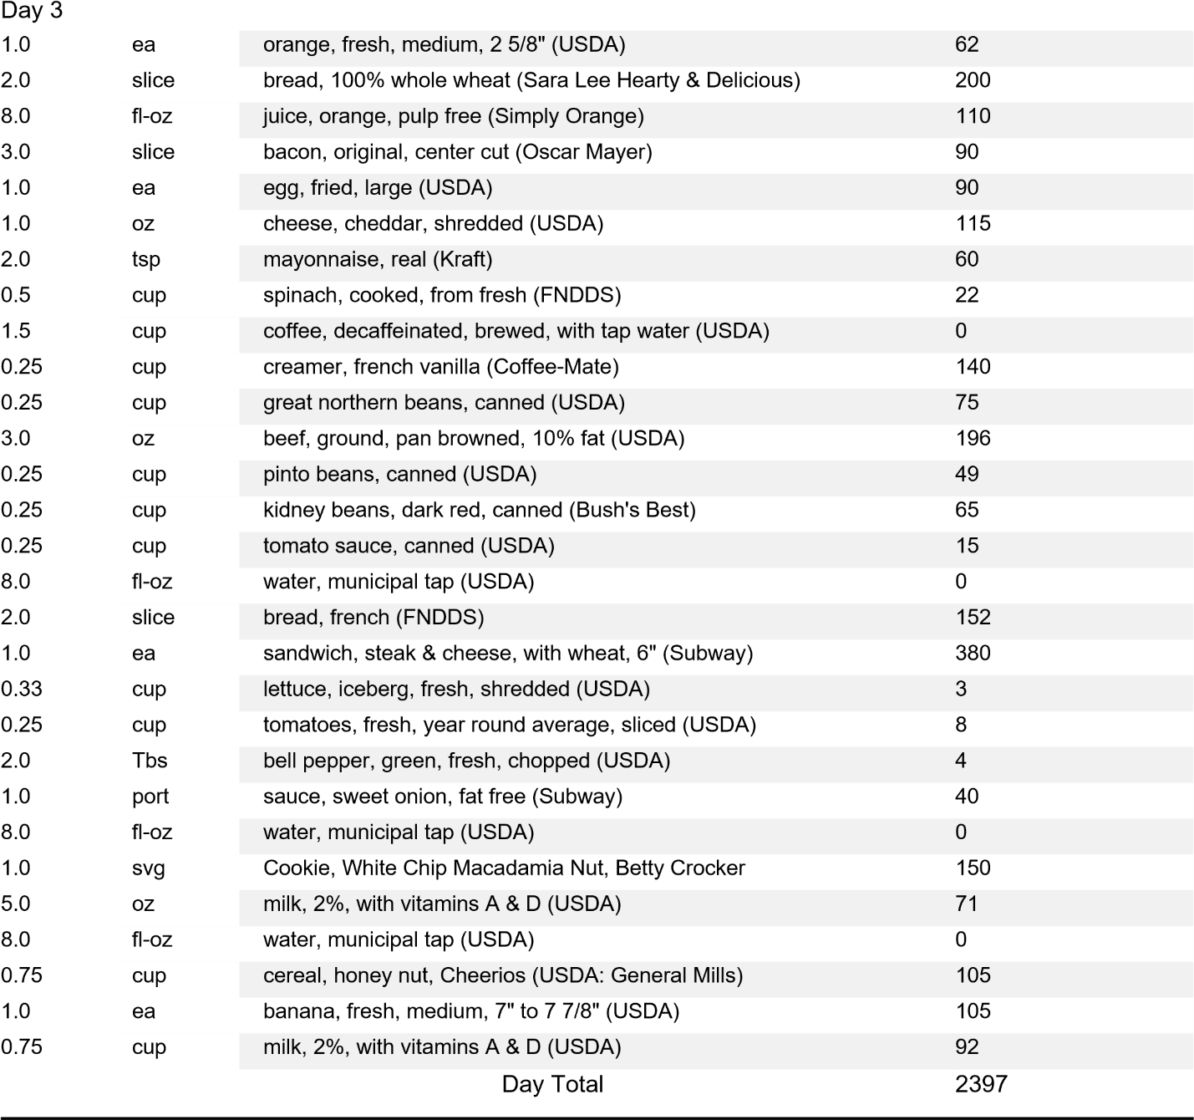
Total | 6052
Day Average | 2017
Item Average | 92

UNIVERSITY OF SOUTHERN INDIANA
SCHOOL OF NURSING AND HEALTH PROFESSIONS
NUTR 376: Principles and Applications in Nutrition

Diet Diary Project – Part 3

Michaela Jones

Question 1
According to Blake, Munoz, and Volpe (2018) in Nutrition: From Science to You, the five key principles of healthy eating are balance, variety, moderation, as well as eating nutrient dense foods that are low in energy density. I did okay with moderation and controlling my portions, however, my diet was lacking in balance. My meals were heavy in carbohydrates and protein since I ate significantly more grains and proteins than fruit, vegetables, and dairy. To better meet the principles of healthy eating, I could have included fruit in my breakfast. If I would have added a green smoothie in my diet each day, I could have reached the recommended amount of fruits, and it would have easily added at least an additional cup of vegetables as well. Another strategy would be to snack on vegetables during the day instead of sodium-packed, energy dense chips. If I would have taken time to plan my meals, I’m sure I would have consumed more nutrient dense meals.
Question 2
DRI is an acronym for Dietary Reference Intakes (Blake et al., 2018). DRI’s provide us with a template for determining the amount of each nutrient we should be consuming. They are individualized by gender and life stage for the most accuracy. The reference values covered by the DRIs are the Estimated Average Requirement (EAR), the Recommended Dietary Allowance (RDA), the Adequate Intake (AI), the Tolerable Upper Intake Level (UL), and the Acceptable Macronutrient Distribution Range (AMDR). The Estimated Average Requirement is the amount of each nutrient required for 50% of Americans to meet their nutritional needs. It is determined by assessing how we respond to more or less of a nutrient, and the amount needed to prevent or fight disease. The Recommended Dietary Allowance is based on the EAR. It increases the amount recommended by the EAR to account for a larger variety of individuals, not just those who are healthy, like the EAR averages. The Adequate Intake relies on up-to-date research and is set by the Food and Nutrition Board. It is not based on population averages, making it independent of EARs, unlike RDAs. The Tolerable Upper Intake Level lists the highest amounts of each nutrient we can consume without experiencing negative or harmful effects. It is important to know these amounts especially when consuming supplements. The Acceptable Macronutrient Distribution Ranges are the recommended percentage ranges of the three macronutrients (carbohydrates, fat, and protein) that our diet should follow to maintain energy needs (Blake).
Question 3
Table 1.
Dietary Guidelines | Met Guideline | Did not meet Guideline | Possible changes for improved intake to meet Guidelines
1. Follow a healthy eating pattern across the lifespan. | I added vegetables to some of the choices that weren’t as nutritious. | I did not have consistency in my mealtimes. | -implement a meal schedule  -get into the habit of making good choices  -limit processed foods
2. Focus on variety, nutrient density, and amount. | I stayed within an appropriate kilocalorie range. | The foods I ate were mostly carbohydrates and protein, but I lacked having enough amounts of vegetables and fruit. | -increase consumption of nutrient dense food  -find substitutions where possible  -have multiple foods from each category  -follow suggested serving size listed on label
3. Limit kilocalories from added sugars and saturated fats and reduce sodium intake. | I did not consume snacks high in processed sugar. | My diet was high in saturated fat and sodium between the cheeseburger, fries, and tomato soup. | -season with herbs instead of salt  -smaller portions of foods with added sugar, saturated fats, and sodium  -follow MyPlate guidelines
4. Shift to healthier food and beverage choices. | Most of the fluids I consumed was water. | I didn’t make easy swaps such as a baked potato instead of fries. | -drink coffee without sugar, or a reduced amount  -herbal tea instead of sweet tea  -replace beef burgers with turkey burger to limit saturated fat
5. Support healthy eating patterns for all. |  | I didn’t provide healthy options for my husband nor did I encourage friends who ate with me to choose a healthier option when we had fast food. | -When going out with friends, know which options are more nutritious and choose restaurants which have more on their menu than fried food.  -pack healthy snacks to share with friends
There are many reasonable steps I can take to improve my diet and meet the Dietary Guidelines. The first guideline is to follow a healthy eating pattern across the lifespan (Blake et al., 2018). This means getting into the habit of consciously making good food choices. If I start the morning with a game plan and map out my meals and snacks for the day, I will not have to make quick or last-minute decisions. If I continue with this routine, it will become a lifestyle for me. When we adapt a healthy eating pattern, we consume an appropriate number of kilocalories. By mapping out meals, I can control my kilocalorie intake. I can also decide on the times I will eat so I can get my body on a schedule. It is important to establish a healthy eating routine because without one, it’s easier to give into fast food. The second dietary guideline is to focus on the amount of food consumed, eating a variety of foods that are nutrient dense (Blake). We should not only consume foods from each group, but a variety within each group to ensure we are obtaining the nutrients our bodies need. I did poorly in this area. I lacked eating a variety of fruits and vegetables, and although I consumed some each day, I didn’t meet the recommended amount. To improve the quality of my caloric intake, I could eat more nutrient dense foods. For example, the day I ate the white chip macadamia cookie, my favorite flavor of cookie, I could have eaten my favorite fruit, a mango. While both a mango the cookie has about 200 calories, mangos have vitamins and fiber, whereas the cookie has processed sugar and more fat. Replacing processed sweets with a piece of fruit is an easy way I can eat foods that are more nutrient dense while also satisfying my sweet tooth. This ties in with the next guideline which is to limit kilocalories from added sugars and saturated fats, and to reduce sodium intake (Blake). Since salt and sugar are used as preservatives, if I limit the amount of processed foods that I’m eating then I should be able to stay within a healthy range. Also, checking food labels will help me see how much I am consuming and will help me in my daily meal planning. Beverages are the easiest way for me to consume large amounts of sugar. I love specialty coffees, so one way I can reduce processed sugar in my diet is to have smaller amounts when I drink coffee, and to sweeten it less. Simple swaps such as using ground turkey instead of beef would dramatically reduce my saturated fat intake, and seasoning with herbs instead of salt would decrease sodium consumption.
Question 4

Table 2.
Nutrient | My  Actual Intake Amount/Unit | My  Recommended  Intake  Amount/Unit | Which Reference Value?  (EAR, RDA, AI, UL, AMDR) | My  DRI Met or Not Met?
Protein | 92.13g | 43.54g | AMDR | Met
Carbohydrate | 250.15g | 291.77g | AMDR | Not met
Calcium | 1,051 mg | 1,000 mg | RDA | Met
Iron | 14.25 mg | 18.00 mg | RDA | Not met
Cholesterol | 242.50 mg | 300.00 mg | RDA | Not Met
Total Fat | 72.90g | 66.02g | AMDR | Not Met
Saturated Fat | 23.46g | 21.22g | AI | Not Met
Folate | 353.72 mcg | 400.00 mcg | RDA | Not Met
Fiber | 20.99 g | 29.71 g | AI | Not Met
Vitamin D | 4.49 mcg | 15.00 mcg | RDA | Not Met

Question 5

My Intake vs Recommendation Report showed a 2,200-calorie pattern. When comparing the bars on the graph, the largest difference was in my fruit intake. I came closest to the recommended grain intake, going only slightly over, and the same was true with protein. My diet does not have proportionality because the main food choice at my meals tends to revolve around grains and protein. Many meals go by without vegetables, and when I include them, they are usually just a topping for a sandwich and not a side. During the 3-day meal tracking period, there was one day that I didn’t even eat fruit. My recommended calorie pattern suggests having 7 oz of grains which I met by consuming 7.7 oz. It is recommended that I have 3 cups of vegetables each day, but I fell short of meeting this goal because I only had an average of 1.7 cups each day. I also did not meet the 2.0 cup requirement for fruit, instead only having about half as much at 1.1 cups. I only consumed 2.2 cups of dairy, whereas it should have been closer to 3 cups. Lastly, my protein intake of 7.0 oz exceeded the recommendation of 6.0 oz.

Question 6

AMDR stands for Acceptable Macronutrient Distribution Ranges (Blake et al., 2018)

$$2,122 \left(kcals\right) x 0.45=955 \left(kcals\right)$$

$$2,122 \left(kcals\right) x 0.65=1379 \left(kcals\right)$$

This means that for carbohydrates:

$$955 \left(kcals\right) ÷ 4 kcals/gram=239 grams$$

$$1379 \left(kcals\right)÷ 4 kcals/gram=345 grams$$

My carbohydrate intake was 250.15 g. This is within the 239-345 g range. To find the percentage of carbohydrates in my diet:

$$250.15 g carbs x \frac{4 kcals}{1 g carbs}=1,000.6 kcals of carbs$$

$$\frac{1,000.6 kcals of carbs}{2,017 total calories}x 100\%=49.61\%$$

The average amount of carbohydrates I consumed was within the 45-65% of my total kilocalories. While I met the recommendations, I ate more grains on average than I needed. To better meet my recommendations for some of the other food groups which provide carbohydrates, I could switch some of the grains for vegetables, fruits, and dairy, which are the groups I fell short in. For instance, instead of having a hamburger bun, I could use leaf lettuce. Many restaurants are happy to make this switch for free. When I make spaghetti, I could use zucchini noodles. Instead of ice cream, I could have Greek yogurt with berries, and instead of a biscuit, I could eat a bowl of oatmeal with chopped apple and cinnamon. With these switches, my carbohydrates would be more nutrient dense.
Glucose from carbohydrates is converted to glycerol and fatty acids, which are then combined into a triglyceride and stored in adipocytes (Blake et al., 2018). Consuming excess carbohydrates results in more storage in the adipocytes which will cause weight gain. When following a low carbohydrate diet, one is often leaving out foods that not only fuel us with energy, but also important nutrients. Consuming too little carbohydrates leads to ketosis, impairment of the brain and nerve functions, as well as the liver and kidneys (Blake). I consumed an average of 250 g of carbohydrates each day, which was well above the 130 g mark in which ketosis would occur.

Question 7

Based on the DRI and my age group, I should consume 46 grams of protein daily. Based on my weight of 120 lbs., my RDA for protein is 43.6 g as calculated below. I consumed an average of twice this amount.

$$120 lb÷ 2.2=54.54 kg$$

$$54.54 kg x 0.8g=43.6 g protein$$

Based on the AMDR, between 212 and 743 kcals should be protein as shown below.

$$2,122 \left(kcals\right) x 0.10=212 \left(kcals\right)$$

$$2,122 \left(kcals\right) x 0.35=743 \left(kcals\right)$$

To find my range of recommended protein intake from the AMDR:

$$212 \left(kcals\right) ÷ 4 kcals/grams=53 grams$$

$$743 \left(kcals\right)÷ 4 kcals/grams=186 grams$$

My measure of protein consumption as 10-35% of total kilocalories is 212-743 kcals or 53–186 grams of protein. My protein consumption was within the AMDR range. From my protein intake calculations, my protein consumption of 93.12 g is above the RDA of 43.6 g, but within the AMDR.
It is thought that excessive protein consumption contributes to an increased risk of “heart disease, kidney stones, osteoporosis, and some types of cancer” (Blake et al., 2018). On the other hand, inadequate protein consumption creates a reduction in the regeneration of digestive cells which can lead to bacteria contaminating the blood (Blake). Protein deficiency can also cause kwashiorkor, a buildup of fluids in the stomach, legs, and feet (Blake). Kwashiorkor causes a loss of muscle tone and strength, as well as dry skin that may be covered in rashes in legions. Unfortunately, I’ve witnessed the devastating effects of kwashiorkor firsthand during a mission project in the slums of Kibera in Nairobi, Kenya.
A complete protein is a protein that “provides all nine of the essential amino acids, along with some of the 11 nonessential amino acids” (Blake). Protein from animal products are forms of complete protein (Blake). Plant proteins are incomplete proteins because plants do not provide us with all the essential amino acids (Blake).

Table 3.
Complete Protein Sources | Complementary Protein Sources
bacon  2% milk  cheese  beef  chicken  eggs | spinach  romaine lettuce  tomato  leaf lettuce  green bell peppers  cheerios  pasta  100% whole wheat bread  rice  great northern beans  kidney beans

Question 8

It is recommended that the maximum amount of cholesterol I consume is 300.00 mg. I stayed under my limit as my average cholesterol consumption was 242.50 mg, or 81% of my limit. When we think of cholesterol, usually we think of the negative effects it plays in heart disease. However, it has positive functions as well. One of its roles in humans is that it is the starting material in the production of steroid hormones, such as sex hormones and adrenal corticoids. It is used by the liver to create bile and is a forerunner in the production of vitamin D. It also contributes to the firmness and fluidity of cells. Consuming cholesterol rich foods in our diet to reap its health benefits is not necessary because the liver can produce all that we need. The previous Dietary Guidelines for Americans (DGAs) suggested consuming less than 300 mg of dietary cholesterol in order to reduce the risk of cardiovascular disease. However, the current DGAs did not give any recommendations for cholesterol consumption because it is now believed that dietary cholesterol does not play a significant role in our blood cholesterol. Kris Sollid, RD, from the International Food Information Council Foundation states that blood cholesterol is instead affected by factors such as “physical activity, body weight, intake of saturated and trans fat, heredity, age, and sex” (Sollid, 2015). Based on this current view, it is still recommended that we consume as little cholesterol as possible.

Question 9

The recommended calcium intake is 1,000. mg which I met by consuming 105% of this value with an average of 1,051. mg. While I did not meet the recommended dairy intake, I was still able to meet the calcium recommendation. Consuming too little calcium could result in hypercalcemia, or excess calcium in your blood, which can lead to kidney issues and calcium deposits. On the other hand, excess calcium could cause an upset stomach, nausea, constipation, bone pain, muscle weakness, and mental confusion. It can also prevent other minerals from absorbing correctly. When we aren’t providing our bodies with dietary calcium, hypocalcemia results. Calcium will be retracted from our bones to be used which can leave them weak and brittle. Weakened bones puts individuals at an increased risk for osteoporosis, osteomalacia, rickets, and bone fractures. It is important to consume an adequate amount of calcium because it is the most abundant mineral in our bodies. It provides us with strong bones and tooth enamel. Calcium is also involved in the function of muscles, nerves, and blood. It may also play a role in lowering high blood pressure, preventing colon cancer, and reducing the risk of kidney stones and obesity.

Question 10

My recommended iron intake is 18.00 mg. My actual intake was lower though, at 14.25 mg, or 79% of what is recommended. My recommended iron intake is 10 mg higher than that of males because women lose iron during menstruation. A vegetarian’s recommended intake would be higher since they would only be consuming one of the two forms of iron. The form vegetarians would consume, nonheme iron, is not as easily absorbed as that which is found in meat.

Question 11

According to my Actual vs Recommended Intakes, I consumed an average of 72.90 g of total fat. My percent of total calories from fat was 32.5% as calculated below:

$$72.90 grams of fat x 9 calories per gram of fat = 656 calories from fat.$$

$$\frac{656 calories from fat}{2,017 total calories} x 100\% = 32.5\% total calories from fat.$$

According to the AMDR, the recommendation for fat intake is 20-35% of daily kilocalories. I was on the upper end of the range, which was due to my consumption of Chick-fil-a and Hardees during the 3-day period, as well as the bacon and ground beef I cooked at home. I made poor choices of protein and could have opted for leaner meats such as chicken and fish instead.

Question 12

On average, I consumed 23.46 g of saturated fat. My percent of total calories from saturated fat was 10.47% as calculated below:

$$23.46 g saturated fat x \frac{9 calories}{1 g fat} = 211.14 calories from saturated fat.$$

$$\frac{211.14 calories from saturated fat}{2,017 total calories} x 100\%$$

$$= 10.47\% total calories from saturated fat.$$

According to the AMDR, the recommendations for saturated fat intake are to consume no more than 10% of your total kilocalories from saturated fats, but to aim for closer to 7% or less. I slightly exceeded the recommended 10%, coming in at an average of 10.47% daily. The items in my MyFoodList Report which are the source of my saturated fat intake are the bacon, ground beef, chicken sandwich from Chick-Fil-A, Yakitori chicken with Japanese style fried rice?, cheeseburger and fries from Hardees, and the white chocolate chip macadamia cookie from subway.. In other words, mostly the fast food. It is important to consume low levels of saturated fat in our diets because they play a role in raising our LDL cholesterol levels and lowering our HDLs.

Question 13

Table 4A. Vitamins
Vitamins | (a)  RDA/AI | (b)  Dietary Intake | (c)  Supplement Intake | (d)  Total Intake | (e)  UL | (f)  % RDA/AI
Vitamin D | 15.00 mcg | 4.49 mcg | N/A | 4.49 mcg | 100 ug/d | 30%
Folate | 400.00 mcg | 353.72 mcg | N/A | 353.72 mcg | 1,000 ug/d | 88%
Niacin | 14.00 mg | 10.93 mg | N/A | 10.93 mg | 35 mg/d | 78%
B 12 | 2.40 mcg | 3.43 mcg | N/A | 3.43 mcg | Not determined | 143%

Table 4B. Vitamins / Intakes
Vitamin / Intakes | LOW  < 75% | OKAY  75-150% | HIGH  >150% | EXCESS  Above UL
Vitamin D | x
Folate |  | x
Niacin |  | x
B 12 |  | x

Table 4B shows that my intake of folate, niacin, and B12 was okay, but my vitamin D intake was lower than recommended. None of these vitamins were consumed in excess. Food sources for vitamin D are salmon and Vitamin D fortified milk. Asparagus and broccoli are good sources of folate. Niacin is found in tuna fish canned in water, and cheerios. Lastly, B12 is in Total Raisin Bran cereal as well as soy milk.

Question 14
Table 5A. Minerals
Minerals | (a)  RDA/AI | (b)  Dietary Intake | (c)  Supplement Intake | (d)  Total Intake | (e)  UL | (f)  % RDA/AI
Calcium | 1,000 mg | 1,051 mg | N/A | 1,051 mg | 2,500 mg | 105%
Iron | 18.00 mg | 14.25 mg | N/A | 14.25 mg | 45 mg | 79%
Potassium | 4,7000 mg | 2,467 mg | N/A | 2,467 mg | Not determined | 52%
Sodium | 2,300 mg | 4,269 mg | N/A | 4,269 mg | 2,300 mg | 186%
Table 5B. Minerals / Intakes
Mineral / Intakes | LOW  < 75% | OKAY  75-150% | HIGH  >150% | EXCESS  Above UL
Calcium |  | x
Iron |  | x
Potassium | x
Sodium |  |  |  | x

The UL for sodium is 2.3 g or 2,300 mg/day. My intake was double the UL due to my consumption of canned soup, microwave-ready items, and fast food. A diet low in sodium is beneficial because you are less likely to have high blood pressure, or hypertension, which means you are at a lower risk of heart disease, stroke, and kidney disease. In addition, by lowering your sodium intake, you can avoid sodium induced fluid retention, weight gain, stomach ulcers, and stomach cancer.
Good food sources of calcium are kale and cheese. Oatmeal and quinoa are iron hearty. Potassium is found in baked potatoes with skin left on and dried apricots, and good low sodium choices are unsalted pretzels and roasted chicken breast without the skin.

Question 15

My average 3-day intake of fiber was 20.99 g. My AI for fiber is 25.0 g. I did not meet my AI for fiber due to the lack of consumption of fruit, vegetables, and whole grains. Three health benefits of fiber are a reduced risk of constipation, heart disease, and obesity. My fiber requirement based on 14g fiber / 100 kcal intake is 308 g as calculated below:

$\frac{g fiber}{kcal intake}=$ $\left(\frac{14 }{100}\right)$($\frac{X}{2,200})$

$$(100)(x) = (14)(2,200)$$

$$\frac{100x}{100}=\frac{30,800}{100}$$

$$x=308$$
Question 16

I consumed an average of 1,396 ml of water. My AI is 2.7 L or 2,700 ml which means I only consumed half as much water as I need. The four factors that influence an individual’s water needs are physical activity, diet, gender, and environmental factors. The more physically active an individual is, the more they lose water, meaning they will need to replace it at a higher rate than one who lives a sedentary lifestyle. In a similar fashion, environmental factors such as temperature and humidity will also contribute to how much water we lose through perspiration. Consuming a diet plentiful in fruit and vegetables contributes to water intake as many foods from these groups are comprised mainly of water. Lastly, since males and females have different body compositions, adult males need to consume more water than adult females. Water is essential to life because it is the most abundant substance in our bodies. It plays many crucial roles including aiding in digestion and the transportation of waste, maintaining a constant body temperature, and lubricating and protecting our joints.

Question 17

A long-term goal to meet my food recommendations would be to increase my fruit and vegetable intake. If I begin to incorporate items from these food groups into each of my meals and snacks, I believe I can reach this goal. This is something I’ve already began doing since reviewing my reports and seeing how my “American diet” has failed to provide me with all the nutrients I need. Two short-term goals of mine are to reduce saturated fat and sodium intake. My sodium intake was the most shocking to see. Both include decreasing the amount of fast food I consume. To reduce saturated fat, I plan to replace ground beef with ground turkey. I will also season my food with herbs and spices instead of primarily with salt in order to cut back on sodium consumption.
One of my weaknesses during this project was feeling very ashamed of my diet. Seeing how much saturated fat and sodium I consumed, as well as how little fruits and vegetables made me question if I was even someone who could help lead others one day. However, one of my strengths was listing the correct items and quantities I ate, as well as continuing my normal diet instead of changing it during the 3-day period to look better. Since numbers in my actual intake list are accurate, at least now I know the specific areas I should work on.
The MyDietAnalysis feature taught me a lot about the breakdown of my diet and how technology can be used to better my health. I found it to be very helpful, especially for tracking micronutrients, which I have a harder time keeping track of. Having spent quite some time digesting the reports and considering how to apply the data to my diet, I believe the information I learned will be useful in both my personal and professional life. I plan to repeat the first two parts of the dietary project to see how my revised diet compares to my previous one. Now that I am aware of the nutrients that I need more of, and which foods will provide them, I believe I am better equipped to make nutritious choices. I am also more confident that when I have children, I will be able to feed them balanced meals. In addition, being knowledgeable on how to perform the necessary calculations to find amounts and percentages of nutrients an individual should consume will be very helpful in my future career in the field of nutrition. Overall, I am very pleased with how much this project has impacted my dietary decisions and health.

References

Blake, J., Munoz, K.,Volpe, S. (2018). Nutrition: From science to you. New York City, NY: Pearson.
Sollid, K. (2015). New dietary guidelines: what changed and what stayed the same. International Food Information Council Foundation. Retrieved from: https://foodinsight.org/new-dietary-guidelines-what-changed-what-stayed-the-same/

